# **Risk Management for Power Supply 1A1**

This is a contingency plan for power supply (1A1) in figure 1 that will regulate outputs for both the controller (2U5) and the lighting strip (2U1). The MPPT (1U1) should provide a regulation to the Solar and battery power, however, a separate power supply will be required to split a constant 7.1 VDC, 0 to 1 A power signal to the controller, and a 10 VDC, 0 to 6 A signal to the lighting strip. We determined this to be a primary risk element since it is required for powering all of Unit 2 and is a Dual output power supply.

## Plan B

Since the numbers above are specific to the project and are mainly to minimize power consumption from the battery, if we cannot construct a working power supply by February 19, 2021, we plan to purchase a dual output supply as a replacement. Our goal is to have the purchased supply arrive by February 26, 2021 for the last week of development. Unit 1 can function without the power supply, and Unit 2 is testable using DC power supplies in the lab until we get this one working. Purchasing a DC to DC dual output power supply that supports the appropriate currents and voltages would be outside the $500.00 budget for our group. Purchasing two buck/boost converters would cost between $40.00 and $60.00 plus $5.00 shipping and connecting them to the MPPT output will require one week at most. Our goal to complete this is March 5, 2021.

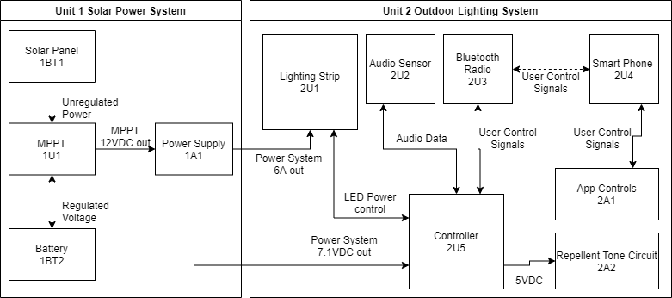

Figure 1. Functional block diagram.